**ME 502 Project Report**

**Project #7 – Thermal Management for BESS**

**Jiong Chen**

1. **Abstract**

A thermal management system is critical for ensuring the safe and efficient operation of a battery energy storage system (BESS) by regulating its temperature to prevent degradation and potential safety hazards. The current work aims at generating a simulation program for a thermal management system of a battery energy storage system. The detailed procedure and control strategy for the simulation has been elaborated. The simulation results include the temperature variation with time, variation in the heat transfer rates between components in the system and the net heat transfer rate of components. The temperature variation includes air, water-EG mixture, battery, devices, frame, and container wall as well as the dew point temperature. The variation of heat transfer rates is between air and each component as well as between water-EG coolant and battery. Except the baseline operating condition, cases of hot weather and extreme battery operating conditions are analyzed. The developed thermal management model can provide critical insight into optimizing the thermal management of the thermal management of BESS.

1. **Introduction**

A thermal management system for a battery energy storage system is essential to ensure optimal performance and safety. It involves regulating the temperature of the batteries to prevent overheating or freezing, which can degrade the battery's performance and lifespan, and even cause safety hazards such as thermal runaway. Typically, the thermal management system includes cooling and heating elements, such as liquid or air cooling, that are designed to maintain the batteries at an ideal operating temperature range. The system also incorporates sensors and control mechanisms to monitor and regulate the temperature, ensuring that it remains within safe limits. Additionally, some thermal management systems may include insulation to reduce temperature fluctuations and prevent thermal shock, which can damage the battery's internal components. Overall, an effective thermal management system is crucial for ensuring the long-term reliability and safety of a battery energy storage system.

In this work, python code with CoolProp package is used to simulate the thermal management of BESS given the operating parameters, heating capacities of components, initial conditions, and operating conditions of the system. The condenser unit is simplified, and the evaporators’ geometries are neglected. First, with the given operating condition, the variation of the system in the following 20 hours is predicted. Then extreme operating conditions and hot weather environment are applied to investigate the impact to the performance of the thermal management system. Key assumption is the lumped capacitance method for the transient conduction analysis of all the components with nonzero thermal capacitance.

1. **Methods and Assumptions**
   1. Operation Conditions and Thermal Properties

The detailed operation conditions and thermal properties of the evaporator are listed in Table 1-3.

Table 1. Suggested ranges of operating parameters

|  |  |
| --- | --- |
| Operating Parameters | Value |
| T_battery_max: the upper limit of battery temperature, [°C] |  |
| T_battery_min: the lower limit of battery temperature, [°C] |  |
| T_air_drybulb_max: the upper limit of air dry-bulb temperature, [°C] |  |
| T_air_drybulb_min: the lower limit of air dry-bulb temperature, [°C] |  |
| T_air_dewpoint_max: the upper limit of air dew point temperature, [°C] |  |
| T_air_dewpoint_min: the lower limit of air dew point temperature, [°C] |  |

Table 2. Heat Capacities of Components

|  |  |
| --- | --- |
| Heat Capacity | Value |
| cp_battery: the specific heat of battery, [kJ/(kg-K)] |  |
| M_battery: the mass of battery, [kg] |  |
| cp_device: the specific heat of devices, [kJ/(kg-K)] |  |
| M_device: the specific heat of devices, [kg] |  |
| cp_frame: the specific heat of frame, [kJ/(kg-K)] |  |
| M_frame: the mass of frame, [kg] |  |
| cp_wall: the specific heat of container wall, [kJ/(kg-K)] | (18 FPI*) |
| M_wall: the mass of container wall, [kg] |  |
| cp_eg: the specific heat of water-EG coolant, [kJ/(kg-K)] | 3.3 |
| M_eg: the mass of water-EG coolant, [kg] | 300 |
| cp_air: the specific heat of air in container, [kJ/(kg-K)] | CoolProp |
| V_air: the volume of air in container, [] | 20 |

Table 3. Thermal resistances between components and air or water-EG coolant

|  |  |
| --- | --- |
| Thermal Resistance | Value |
| R_air_battery: the thermal resistance between air and battery, [K/kW] |  |
| R_eg_battery: the thermal resistance between water-EG and battery, [K/kW] |  |
| R_air_device: the thermal resistance between air and devices, [K/kW] |  |
| R_air_frame: the thermal resistance between air and frame, [K/kW] |  |
| R_air_wall: the thermal resistance between air and wall, [K/kW] |  |

Table 4. Operating Conditions (i.e., boundary conditions)

|  |  |
| --- | --- |
| Operating Conditions | Value |
| T_air_outdoor: the temperature of outdoor air, [°C] |  |
| Q_external: the external heat going to container walls , [kW] |  |
| Power_pump: the power input to pump, [kW] |  |
| Power_fan: the power input to fan, [kW] |  |
| Power_device: the power input to electrically-powered devices, [kW] |  |
| Q_batterygenerating: the heat generated by battery, [kW] |  |
| Q_eg_heater: the heating power of glycol heater, [kW] |  |
| Q_air_heater: the heating power of air heater, [kW] |  |
| m_dot_water_in*: the water vapor penetration, [g/s] |  |

Table 5. Initial Conditions

|  |  |
| --- | --- |
| Initial Conditions | Value |
| T_air_drybulb_0: the temperature of air in container, [°C] |  |
| T_air_dewpoint_0: the dewpoint temperature of air in container, [°C] |  |
| p_air_0: the pressure of air in container, [kPaA] |  |
| T_eg_0: the temperature of water-EG mixture, [°C] |  |
| T_battery_0: the temperature of battery, [°C] |  |
| T_device_0: the temperature of devices, [°C] |  |
| T_frame_0: the temperature of frame, [°C] |  |
| T_wall_0: the temperature of container wall, [°C] |  |

The schematic of the BESS is shown in Figure 1. The condensing unit is used to provide all the cooling capacity to the system in order to maintain the temperature of the system components. There are two evaporators. The 1st evaporator is used for cooling the water-EG loop. The temperature of the water-EG is controlled by the 1st evaporator and the EG heater. Water-EG is used for keeping the battery temperature within the operating range. A pump is used to circulate the water-EG. 80% of the heat generated by the pump is absorbed by water-EG and the rest is absorbed by the air. The 2nd evaporator is used for cooling and dehumidifying the air. Since the 2nd evaporator’s cooling capacity is smaller than the capacity of the condensing unit. Thus, the extra cooling capacity must be delivered to the water-EG coolant through the first evaporator to make the condensing unit work well. The air heater is used for controlling air temperature as well. Heat generated by fans, electrical device and also thermal input from wall contribute to the air temperature change.

Figure 1. Schematic of Thermal Management System for BESS

The cooling capacity of the condensing unit is dependent on the outdoor air temperature which is fixed for one case simulation. The relation is:

And the second evaporator’s heat transfer capacity is fixed at 7kW. The sensible heat ratio of the evaporator can be approximated by the air dew point temperature:

for

* 1. Control Strategy

For battery cooling, only when the temperature of battery reaches to the upper limit, the thermal management system will start to cool the battery. And the cooling will be terminated when the battery temperature is lower than 0.5°C of the upper limit temperature.

For air cooling, when either the dry bulb temperature or the dew point temperature reaches the upper limit, the system will start to cool or dehumidify the air. And when both the dry bulb temperature and the dew point temperature are below the lower limits, the cooling process will be terminated. However, when air needs cooling, the 1st evaporator needs to turn on as well. Thus, cooling air represents cooling air and battery at the same time.

There are 3 operating modes of the thermal management system. The 1st mode is when battery and air temperatures are below lower limits, the cooling system is and both evaporators are not working. The 2nd mode is only the 1st evaporator that is operating. This happens when the battery temperature reaches the maximum temperature limit while the air temperatures haven’t reached the upper limit. The 3rd mode is both evaporators are operating. This happens when both battery and air needs cooling or only air needs cooling.

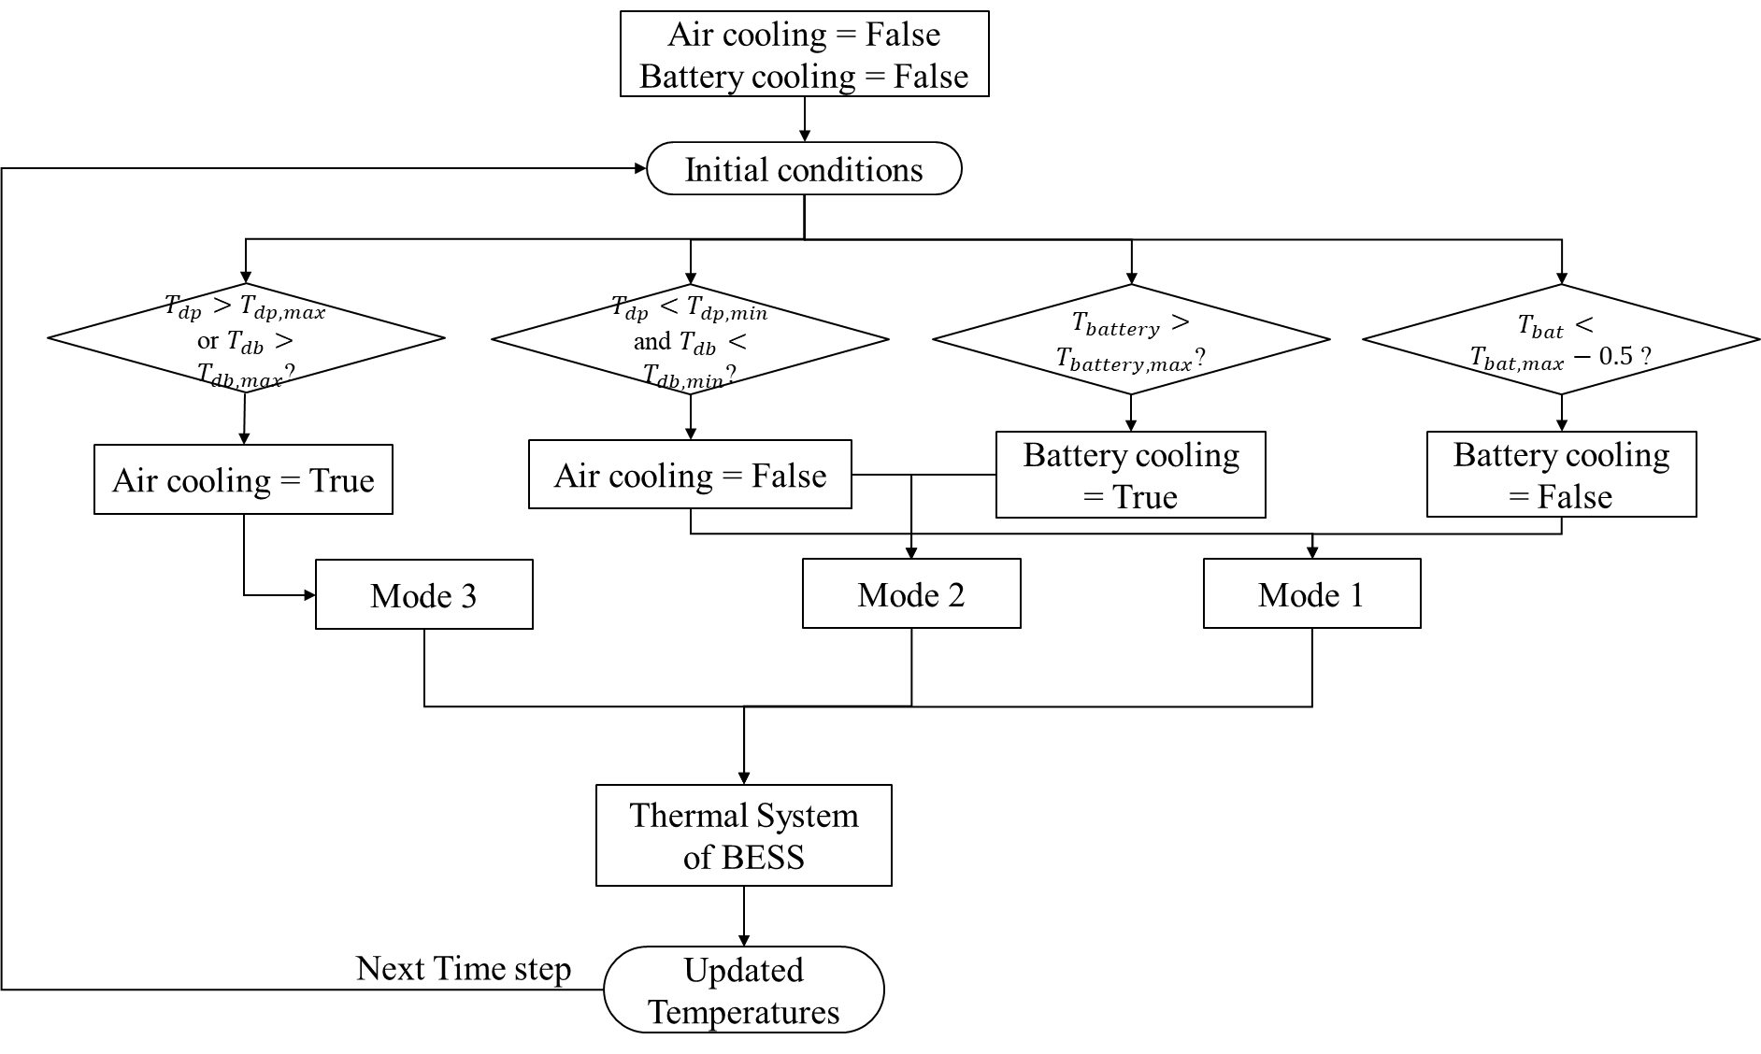

Figure 2. Flow Chart of Control Strategy

Figure 2 shows the control strategy of the thermal system. All the initial components’ temperatures are the input. There are two variables named “Air cooling” and “Battery cooling” which represent the need of cooling for air and battery respectively. Their initial values are “False” which means that air and battery doesn’t require cooling. Then based on initial conditions of the time step, four judgements are applied. The 1st judgement is for air temperatures. If the dry bulb temperature or the dew point temperature are higher than the upper limit, “Air cooling” is set to “True”. And when air cooling is “True”, the thermal system will be mode 3. If the air cooling is not on, then the battery temperature is checked. If the battery temperature is higher than the upper limit, the “Battery cooling” is “True”. However, if the “Air cooling” is on at the time step, the air dry bulb temperature and dew point temperature is checked if it is lower than the lower limit. If both air dry bulb temperature and dew point temperature are lower than the lower limit, “Air cooling” will be set to “False”. Like battery, if initially “Battery cooling” is “True”, and when the battery temperature is cooled below the lower limit, it is set to “False”.

Figure 3. Thermal System Model Concept

Figure 3 shows the thermal system model concept of BESS. There are 6 components - water-EG, battery, air, wall, devices and frame. The transient temperature is calculated by the net energy heat transfer rate, the specific heat and mass of the component. The heater is set to turn on and off, while device continuously generating heat and outside air keep input heat into the system.

1. **Results and Discussion**
   1. Baseline Performance

Figure 4 contains the 1st hour of system component temperature variations. Since the initial given temperature of air is higher than the upper limit, the thermal system is set to be mode 3. After around 10min, both the dry bulb temperature and dew point temperature drop below the lower limit. Since the battery temperature is lower than the upper limit, the system is set to mode 1, two evaporators are off. And after a short time, which is around 10min, the dew point temperature reaches the upper limit, and the system is set to mode 3 again. Since the devices temperature are higher this time, it takes longer time for the air dry bulb temperature to reach the lower limit. From Figure 5, when the system is on in mode 3, after the air temperature drops to around 22, the net heat transfer rate of battery is negative which means the battery temperature is decreasing. Notice that at around 10min, there are some fluctuations, which is because the temperature of the components are very close.

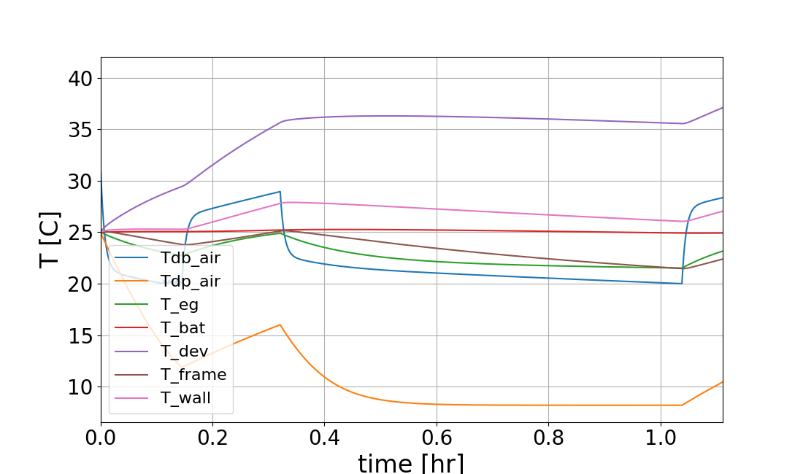

Figure 4. 1st hour system component temperatures

Figure 5. 1st hour net heat transfer rate of components

Figure 6. 1st hour heat transfer rate between components

Figure 4(e) and (f) shows the air side temperature distribution. For condenser side, at the place where refrigerant enters and leaves the two-phase region, there are two sharp changes of air side temperature. I think it is because the heat transfer coefficient is not continuous at the saturated vapor and liquid condition. This can also be reflected from Figure 4(g). For evaporator side, as air gradually cooled by each slab, the temperature dropping rate is slowing down since the temperature difference between refrigerant and air is decreasing. Figure 4(g) (h) (i) and (j) shows the heat transfer rate of evaporator and condenser as well as the sensible heat and latent heat. Condenser has a higher heat transfer rate at the inlet of condenser which is because of the greater temperature difference between the refrigerant and air. And as the refrigerant condensed, the heat transfer rate decreased from 3.7W to 0.9W in each segment. While for evaporator, higher heat transfer rate happens at the 3rd slab and the beginning of the 4th slab, which is because at these locations, refrigerant is two-phase and temperature difference between air and refrigerant is large. From Figure 4(j), at the locations near the exit of evaporator, there is no water condensation happening because the refrigerant temperature is high, so the air-side surface temperature is higher than the dew-point temperature. Although refrigerant temperature is very low at the inlet of evaporator, since water vapor has condensed in 2nd and 3rd slabs, at the 1st slab, the latent heat transfer rate is not the highest which is around 0.3W while the highest rate is 0.68W.

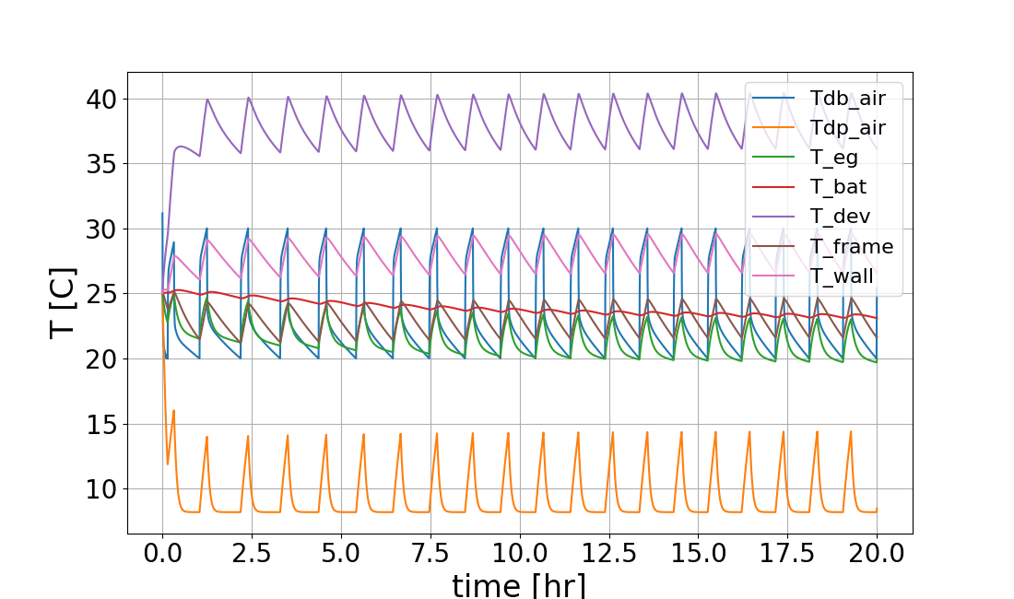

Figure 7. system component temperatures 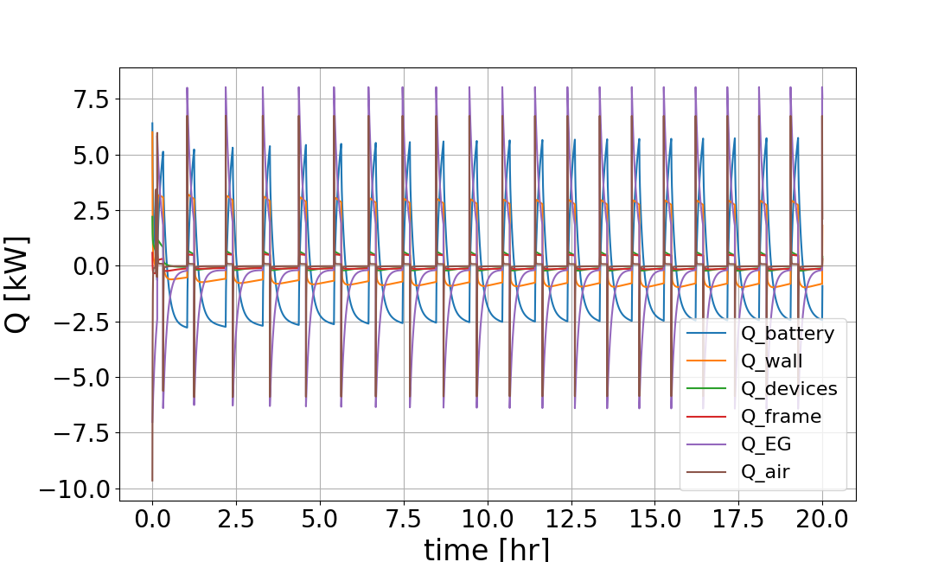

Figure 8. net heat transfer rate of components

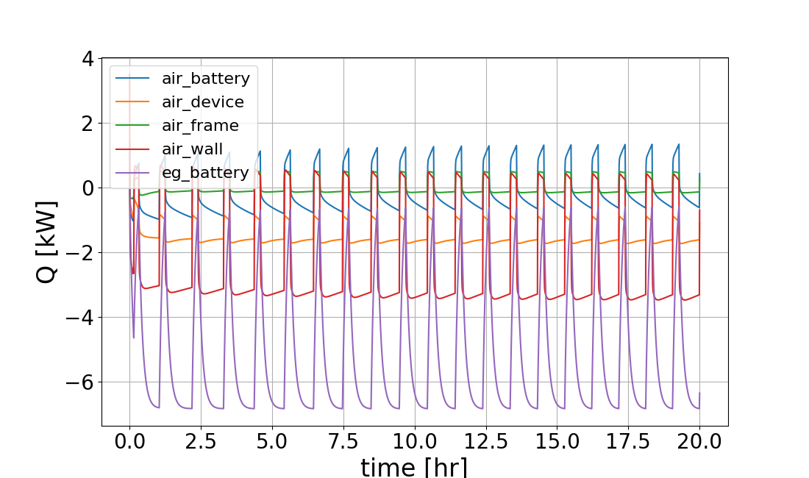

Figure 9. heat transfer rate between components

Figure 7 to 9 shows the system behavior for 20 hours. In Figure 7, except battery temperature, all other components reach “steady” condition and are maintained in certain regions and change periodically. The battery temperature reaches “steady” condition after around 10 hours and maintained at 23.5.

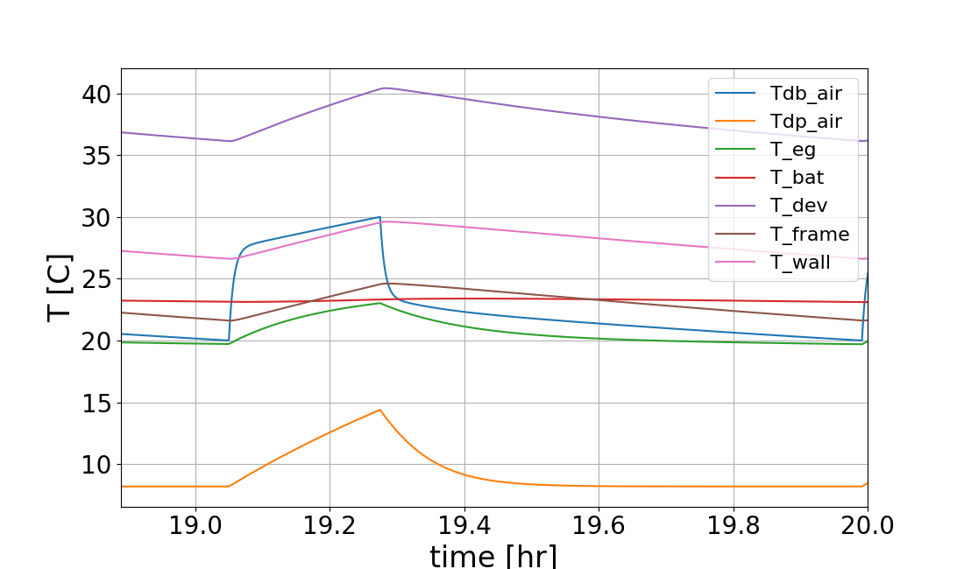

Figure 10. last hour of 20 hours operation - system component temperatures

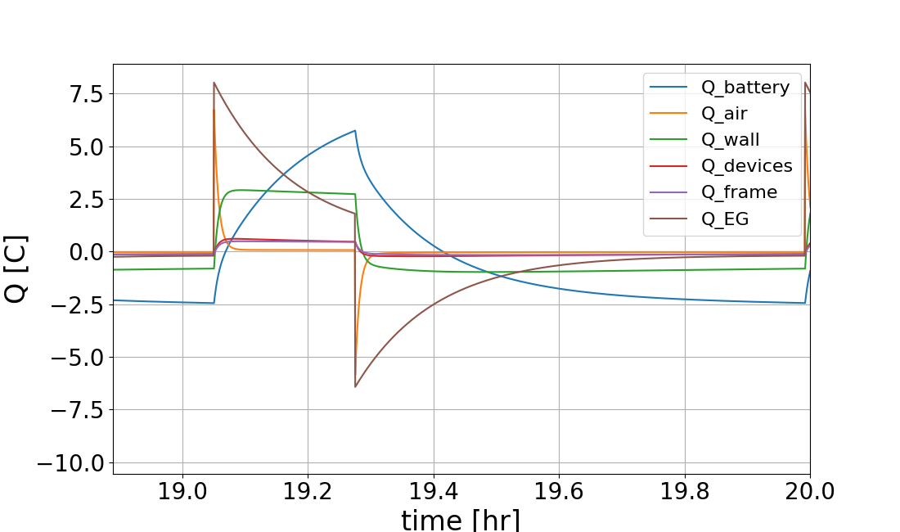

Figure 11. last hour of 20 hours operation - net heat transfer rate of components

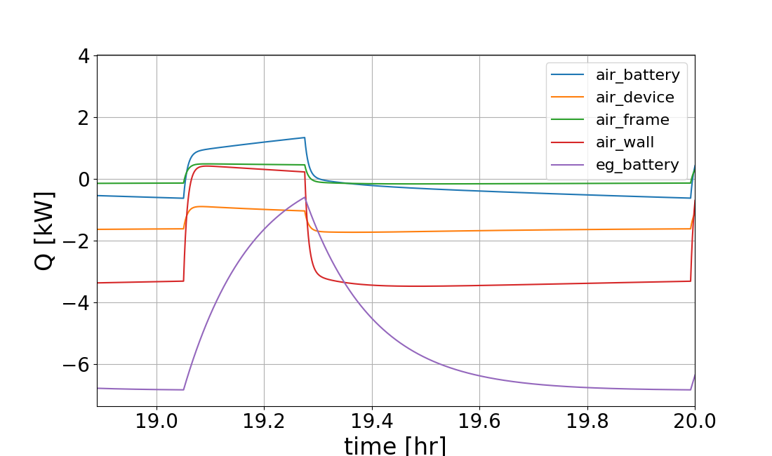

Figure 12. last hour of 20 hours operation - heat transfer rate between components

In the last hour of 20 hours operation, it shows approximately one loop of system cooling. At around 19.03 hour, the air temperatures reach the lowest limit, and the cooling system changes to mode 1. After around 12 minutes, the dry bulb temperature reaches the upper limit, and the cooling system changes to mode 3. And in the later time, the air is cooled to the lowest limit.

* 1. Extreme Condition

Figure 13. Temperature variations of components

Figure 14. Net heat transfer rate of components

Figure 15. heat transfer rate between components

For extreme battery working conditions, the battery generates 9kW power. According to Figure 10, notice that initially, the thermal system can still maintain the air temperature within the required region; however, the battery temperature keeps increasing and cannot be cooled even if the thermal system is at mode 2 (only 1st evaporator is working). Thus, after 12.5 hours, all the components’ temperatures are increasing gradually which means the cooling system cannot maintain the temperature. The heat transfer rate between components in Figure After a long time (more than 30 hours), the battery and electronic devices may be damaged due to high temperatures.

* 1. Hot Weather

For hot weather, the external heat input rate was raised up to 4kW. The difference between the baseline and the hot weather conditions is that the 1st time cooling to desired condition, hot weather case took longer time which is around 9.25 hours while the base condition only takes 1 hour. Besides, the system operating frequency is lower than the base condition. The period of system operation is around 2.5 hours while the base condition is around 1 hour. At hot weather condition, the system can be cooled to target operating temperatures. And the battery temperature is maintained at around 20.

Figure 13. Temperature variations of components

Figure 14. Net heat transfer rate of components

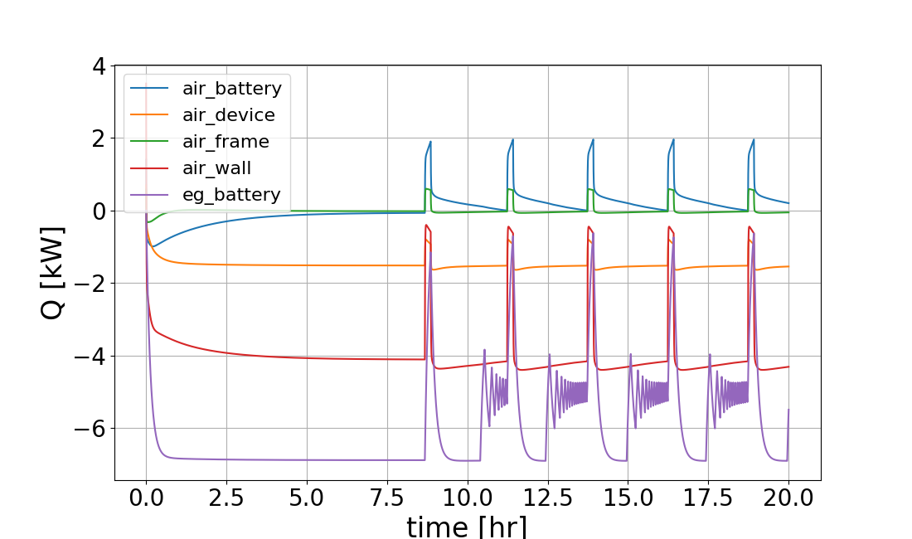

Figure 15. heat transfer rate between components

1. **Conclusions**

The transient thermal system control of BESS was simulated with python and package CoolProp. The baseline performance of the thermal control system was shown. Hot weather conditions and extreme battery operating conditions were investigated and compared. The cooling control system can handle hot weather conditions although the time for cooling to target conditions is longer and energy for cooling increases. For extreme battery conditions, the cooling control system can maintain the temperatures of components within required ranges for around 30 hours. But it can not keep the devices and battery safe under extreme condition for a long time.

1. **References**

Dr. Ke Tang’s Lecture Materials.